ARCHITECTURE

Project Name : ABT

Provider Solution: AWS

I define the architecture for this pipeline, I propose the architecture on AWS.

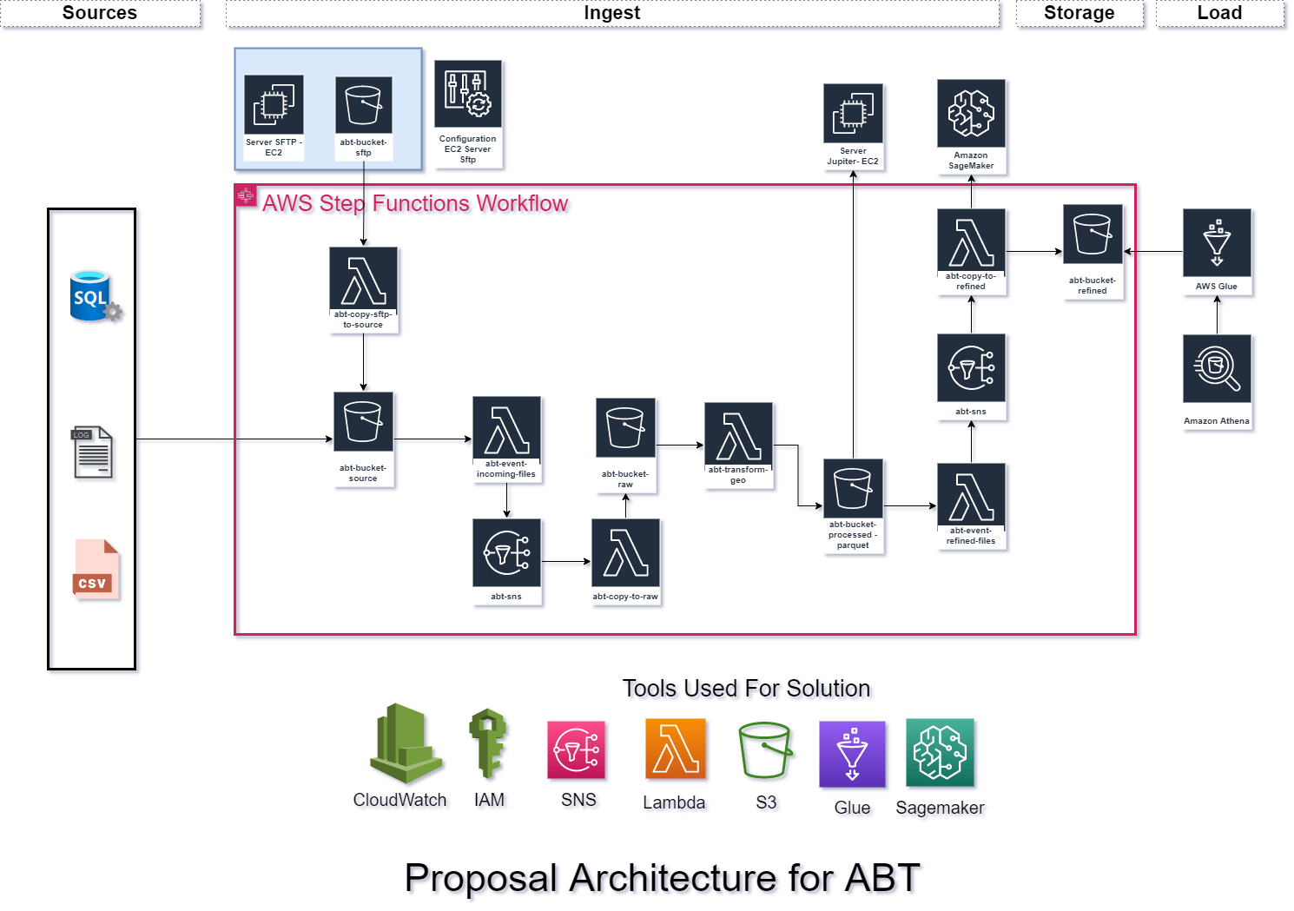

**Point 1:** (Architecture)

You must define the architecture for this pipeline, you can propose the architecture on AWS or GCP. Consider that this architecture should support the addition of similar data sources in later versions taking into account the following points:

* Storages tools and layers that are required (Raw, Staging, Analytics, Curated)

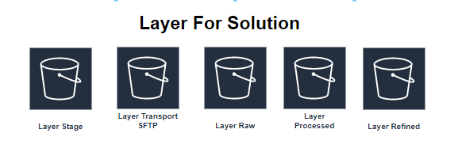

* Tools for transforming the data (Should be cost effective solution, EMR, Glue, Dataflow, DataProc)

**For the architecture Modern: Glue**

* Define the orchestration tool (For instance: Airflow or Step Functions)

**For the architecture Modern:**  **Step Functions**

* Define the notification and alert tool (For instance: Airflow operator or SNS)

**For the architecture Modern: SNS and Event Bridge**

* Define the tool for Data Scientists (For instance: AI Platform, EC2, SageMaker)

**For the architecture Modern:**  **Step Sagemaker or EC2 is more cost effective**

* Define the tool for Business Analytics (For instance: BigQuery, Hive, Athena, RedShift)

**For the architecture Modern:**  **Athena**

* Any other required in your design

IMPLEMENTATION CASE

**Creation of buckets**

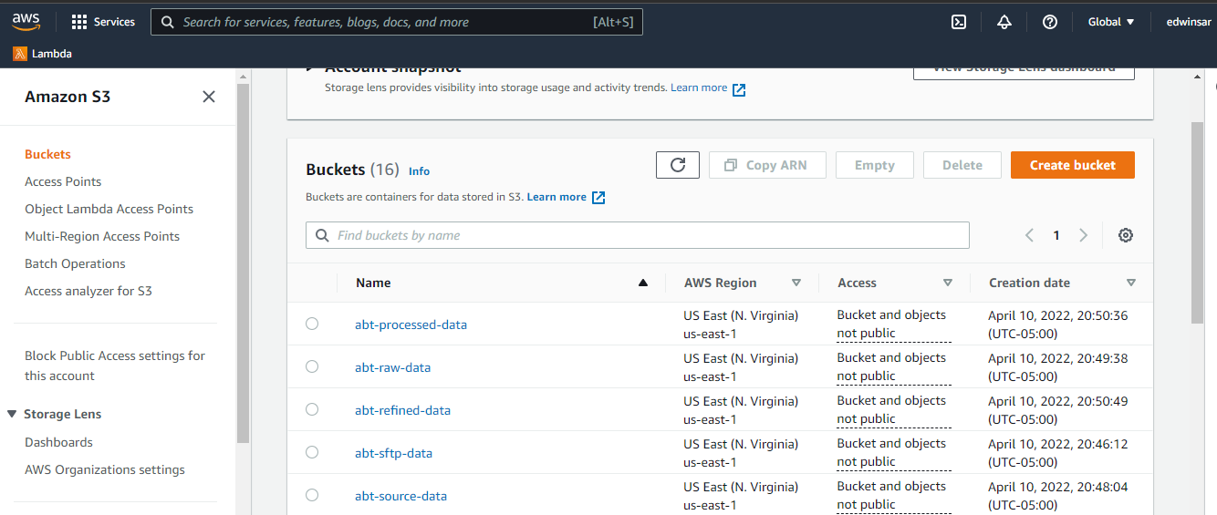

Creation Lambda

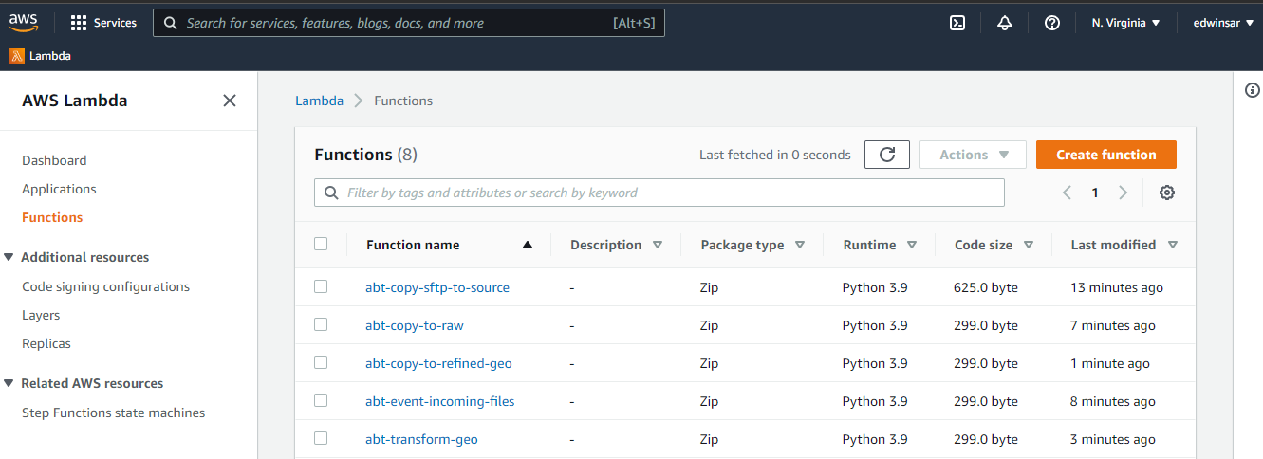

Creation SNS Topic

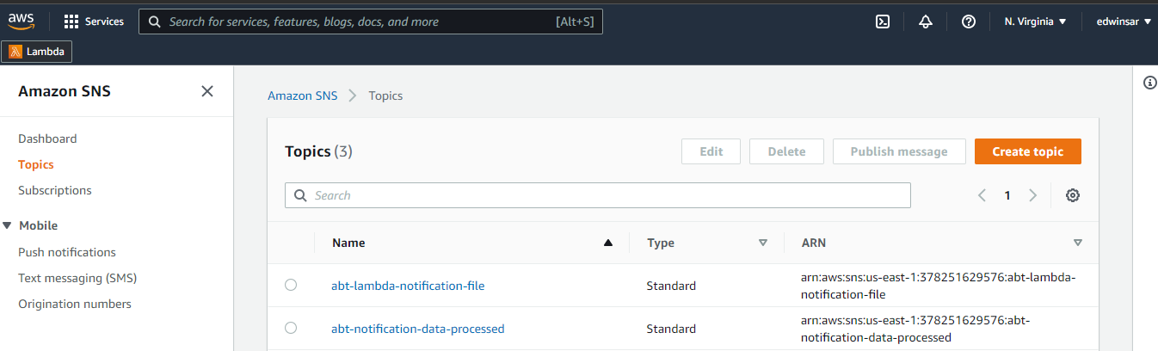

Cloudwatch AWS

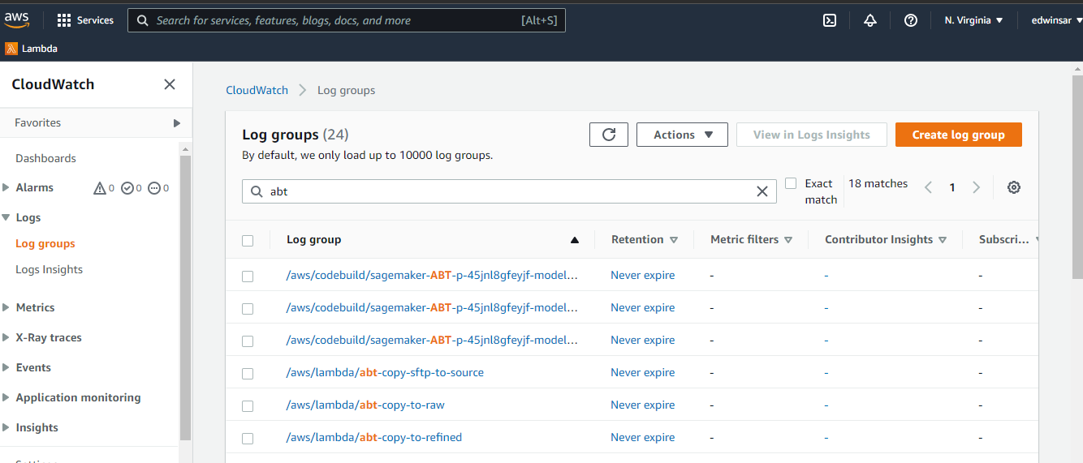

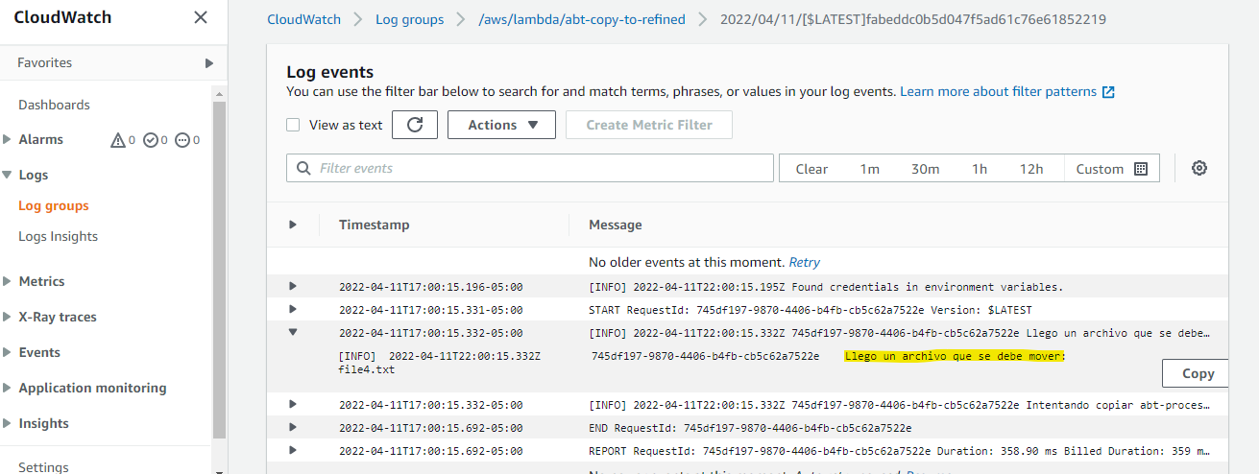

Creation EC2

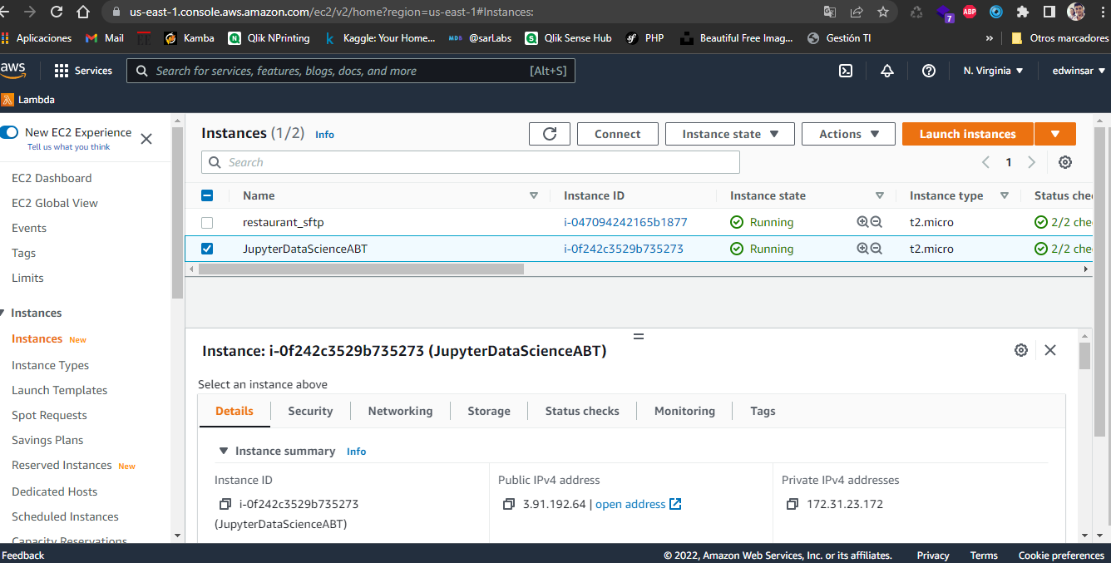

Execution Point 2 - On EC2

